### Starting View

A 2D starting view helps the opening of large models, as 3D views typically require longer to regenerate. A starting view should be employed on all projects to identify the Contract Number, Project Name, Discipline, BIM Manager or Revit Coordinator, File Creation Date, Transferred Date, and key project Team Leads. The SFO Starting View can be found in the SFO Revit Template files. When exchanging the model to consultants, edit the Transferred Date label.

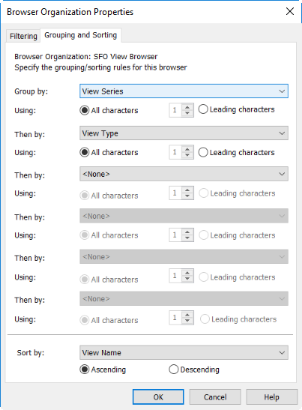

Figure 4.1‑2 SFO View Organization Group/Sorting Rules